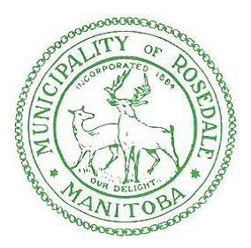

Please be advised that the Rural Municipality of Rosedale has a Burning Ban in effect as of 11:00 AM
Friday, May 14, 2021

UNTIL FURTHER NOTICE – ABSOLUTELY NO BURNING IS ALLOWED WITHIN THE MUNICIPALITY.

Any inquiries, please call 204-476-5414

