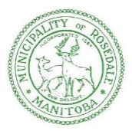
PUBLIC NOTICE
VOTING AS A NON-RESIDENT VOTER

Please be advised that the next general municipal election will take place October 24th, 2018

For municipal elections only, non-resident land-owners are eligible to vote in an election. In order to be eligible, the person must be:

· A Canadian citizen;
· At least 18 years of age on Election Day;
· A registered owner of land in the municipality for at least six months on Election Day.

A maximum of two non-resident property owners, per property, are permitted to vote in a municipal election. In order to vote, each of these voters must obtain written consent from a majority of the registered land-owners, and file this with the senior election official. Consent forms can be obtained from the senior election official, and must be presented at the time of voting.

When voting, you may also be required to provide proof of ownership to the voting official. Ensure you bring proof of ownership with you when voting.
For further information, or to obtain a consent form, please contact the senior election official.

Rural Municipality of Rosedale
Kara Sylvester, Senior Election Official
Phone: (204) 476-5414

