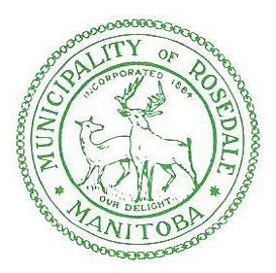

RURAL MUNICIPALITY OF ROSEDALE
BY-LAW NO. 5-2017

BEING A BY-LAW OF THE RURAL MUNICIPALITY OF ROSEDALE TO PRESCRIBE A FEE CHARGEABLE FOR TAX CERTIFICATES

Whereas subsections 341(1) of The Municipal Act provides as follows:

341(1) The fees chargeable for a tax certificate shall be as prescribed by by-law;

AND WHEREAS it is deemed advisable and in the best interest of the municipality to prescribe a fee chargeable for tax certificates.

NOW THEREFORE BE IT RESOLVED, the Council of The Rural Municipality of Rosedale, in regular session assembled, enacts as follows:

1. THAT the fee chargeable for a tax certificate shall be thirty dollars ($30.00) with respect to the land described in each entry in the tax collector’s roll for which a tax certificate is furnished.

2. THAT By-law No. 1-2015 of the Rural Municipality of Rosedale is hereby repealed.

DONE AND PASSED in Council assembled at the Rural Municipality of Rosedale Administration Office, Neepawa, Manitoba this 12th day of January, 2018.

___________________________
Reeve

____________________________
CAO

Read a first time this 8th day of December, 2017.

Read a second time this 8th day of December, 2017.

Read a third time this 12th day of January, 2018.

