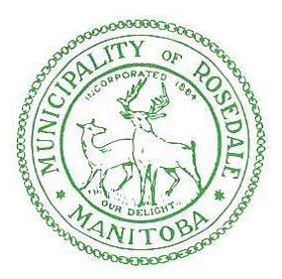

Manitoba Water Services Board has notified the RM of Rosedale that the Eden Water Reservoir will be cleaned and filled for change over on January 2, 2018
Please Note:
This procedure should not cause any disruption to the Eden water service

If there are any questions or concerns, please contact our office at (204) 476-5414

